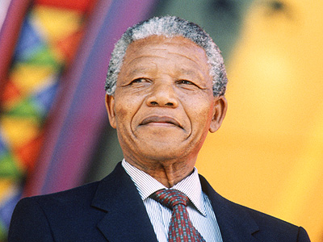
Nelson Mandela
Nelson Rolihlahla Mandela was a very famous man. All people in the world know Madiba because he was the man whose stop the Apartheid and who WAS putted in jail FOR 27 years

Nelson Mandela was born ON 18 July 1918 in Mvezo in South-Africa in a Xhosa ethnic group. When he was 18 years old, he left his group to go to Johannesburg

In Johannesburg, Mandela became a lawyer. He joined the ANC (African National Congress) TO stop the segregation and the Apartheid.

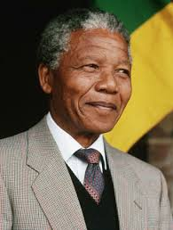
With the ANC, Mandela made a pacific fought against apartheid but the ANC was prohibited / BANNED in 1960. So he began to struggle illegally and made sabotage TO stop segregation.

But in 1962, he was arrested by the South-AfricaN police. He was sentenced to jail and forced TO labor for life. During his IMPRISONMENT; Winnie, his second wife, fought for him. We often forgot that but Winnie always fought even if she was often arrested for the Mandela’s freedom. A lot of stars supported him too like Johnny Clegg. When he was in jail, Nelson Mandela refused to leave jail if what he wanted wasn’t done.

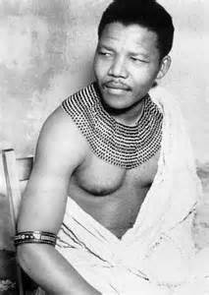After 27 years in jail, Madiba was released the 11 February 1990. After that, he negotiated with De Klerk for the equality of blacks and whites. In 1993, he received, with De Klerk, the Nobel Peace Prize for his fought peacefully against Apartheid

The 9 May 1994 was a famous day for South-Africa because Mandela was elected with 80% of vote and he was the first black South-Africa’s president. DurING his career he wanted to make equalities about blacks and whites . He finishedRETIRED in 1999.
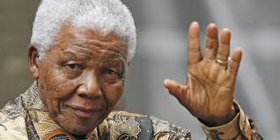 Unfortunately Nelson Mandela died ON the 5TH OF December 2013 AT THE AGE OF 95 years old.
He was a very a intelligent sensible and courageous man and peoples WILL remember him a long time yet

William and Julie 3°7
