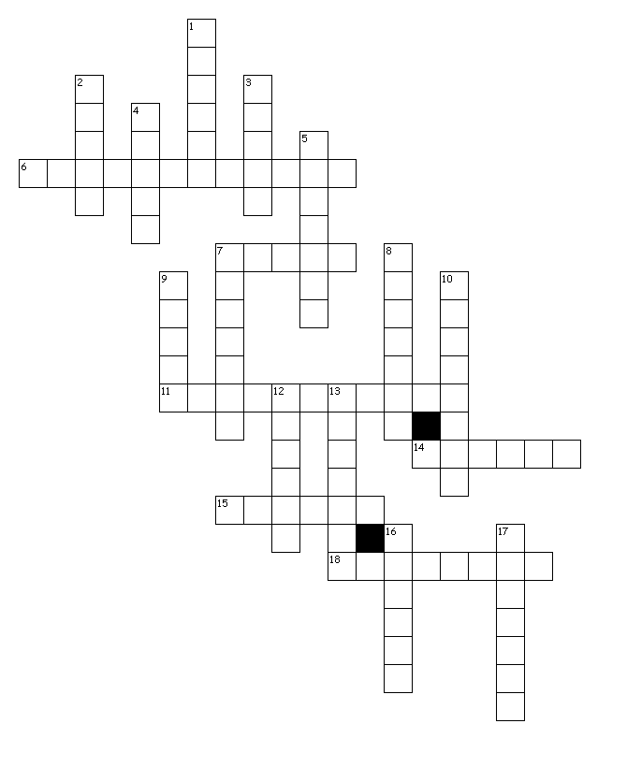
Halloween criss-cross puzzle by the 3ème2

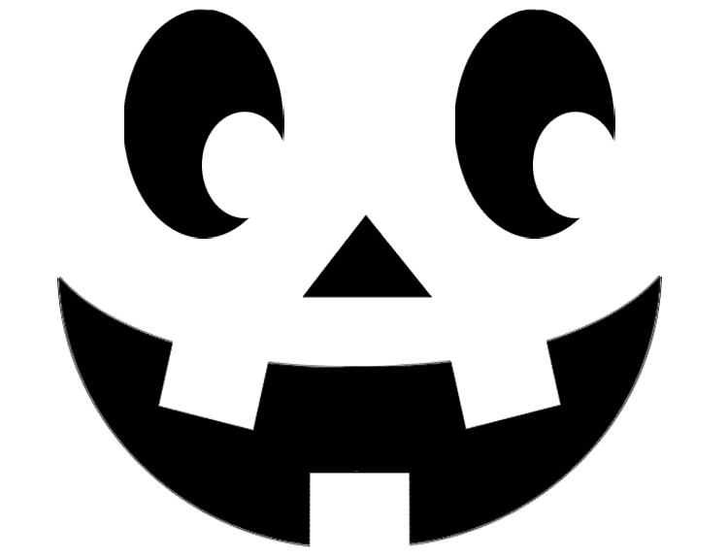

Across
6. It is a vegetable that is orange and
round and where you put a candle, it has got
a mouth , a nose and two eyes
7. someone who has no Christian religion
11. day in October when people celebrate
Halloween and which is the night before All Saints’ Day
14. people who offer sacrifices on the night of November 1st
15. A creature who goes out at night during Halloween
18. A creature who doesn’t have skin
Down
1. it is a goddess who symbolizes the harvests
2. a woman who uses magic
3. A people who started Halloween
4. It’s a person who is dead and scary.
5. A place where Halloween is most celebrated
7. a vegetable which is orange.
8. A Halloween monster that has long teeth , who lives at night and is immortal because he is already dead .
9. day in November where nobody works. It’s a religious day off ( aka All Hallow’s/ Saints’ Day )
10. creatures who are very scary
12. a vegetable which is purple and white.
13. they are small creatures who take the teeth in the US. They also capture people for years on Halloween
16. Creatures that live at night , with a tail and horns
17. a female deity with supernaturalpowers in a polytheistic religion and who most often have female characteristics

